EC2 Instance Creation

1: Launch one Aws ec2 and install Jenkins.
1. $ sudo apt update
2. $ sudo apt install fontconfig openjdk-21-jre -y
3. $ java -version
4. Install the Jenkins repository key:
a. $ sudo wget -O /etc/apt/keyrings/jenkins-keyring.asc \
https://pkg.jenkins.io/debian-stable/jenkins.io-2026.key
5. Install Jenkins
a. $ sudo apt install jenkins -y
6. Start Jenkins
a. $ sudo systemctl start jenkins
b. $ sudo systemctl enable jenkins
7. Check Status of Jenkins
a. $ sudo systemctl status jenkins
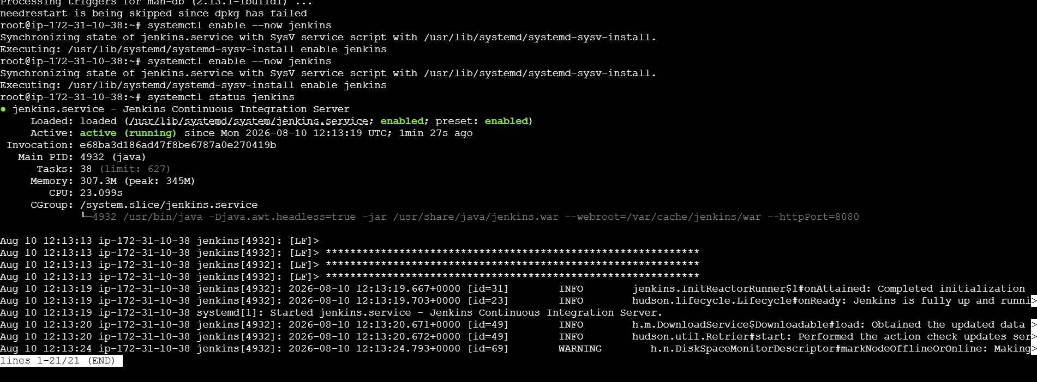

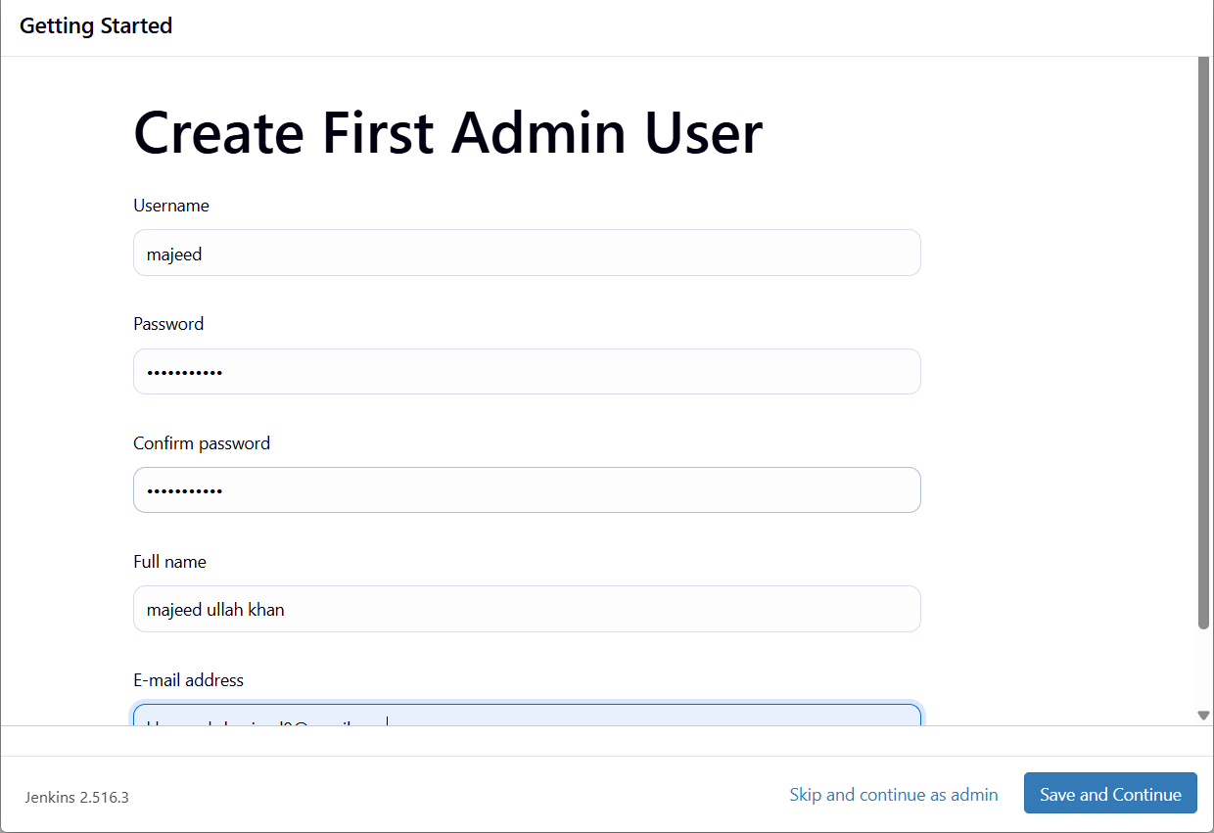
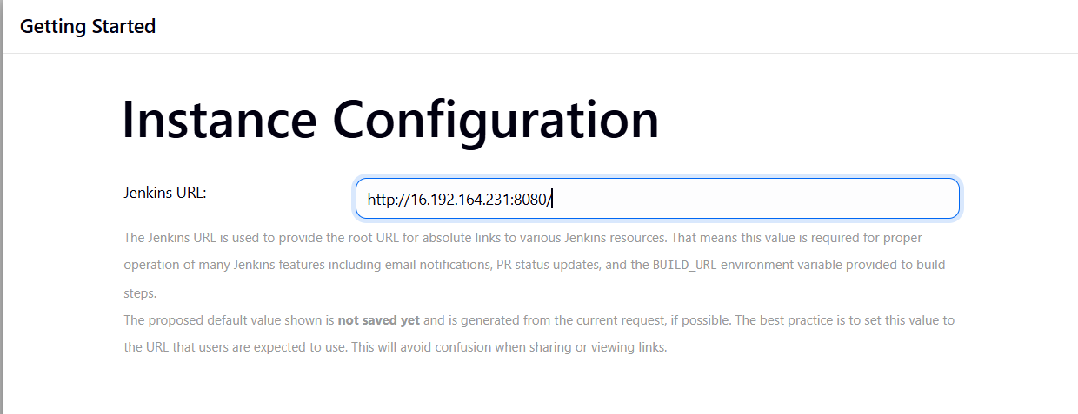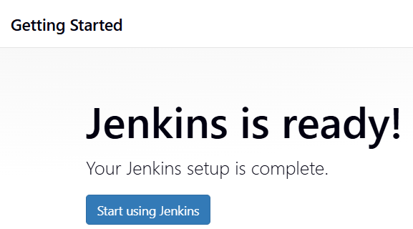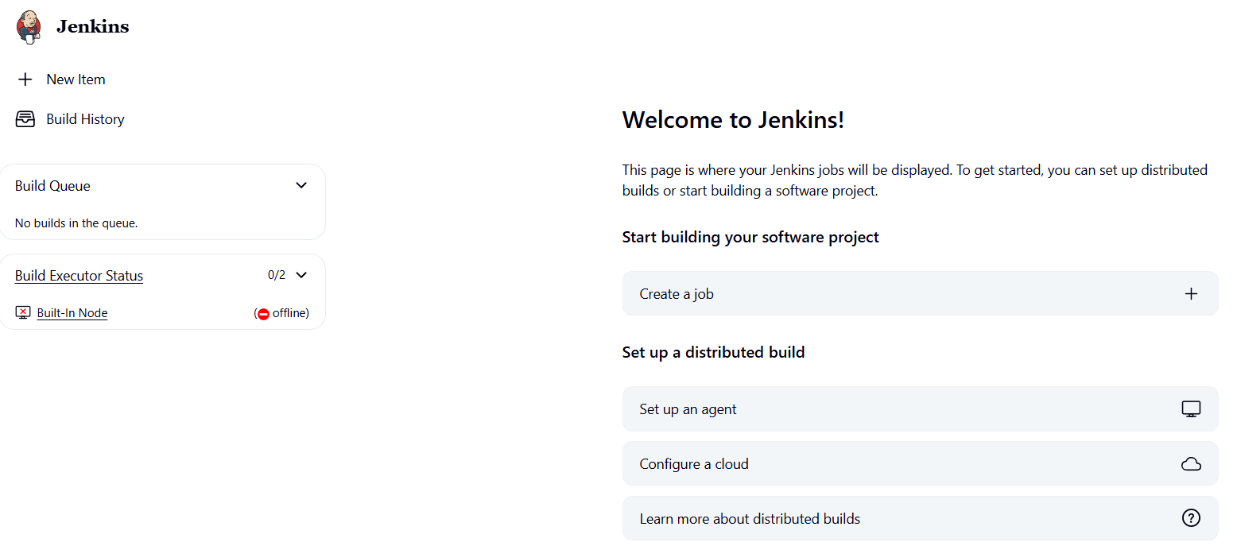
2: Setup Docker Desktop on your local windows.
1: wsl –version
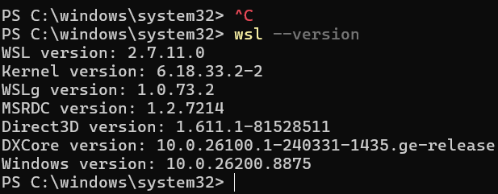
Download Docker Desktop
Open your web browser and go to the official Docker download page:
Download Docker Desktop for Windows
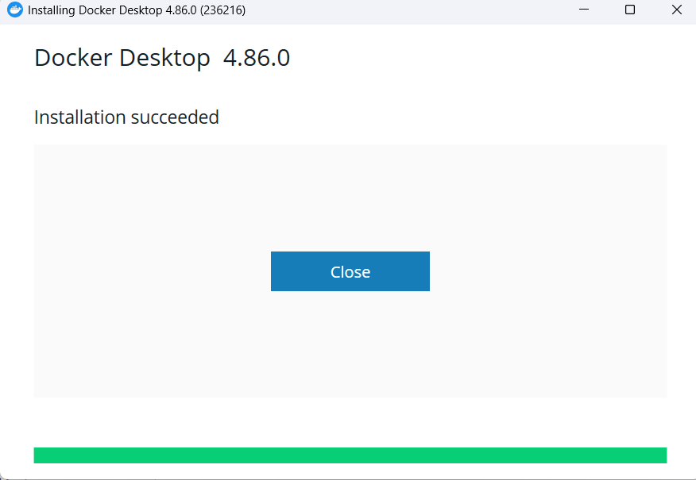
Setup Docker Desktop on my local windows.
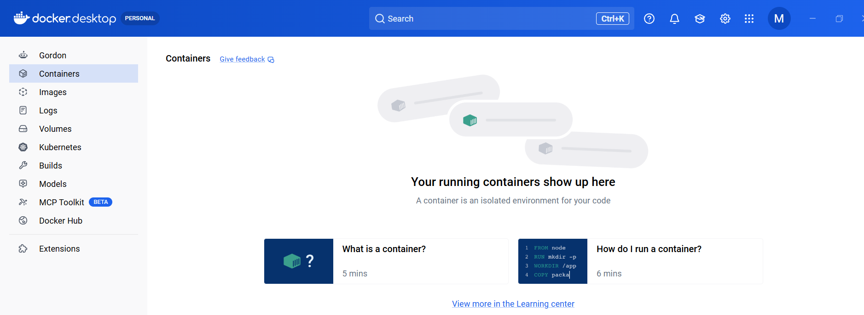
3: Setup Apache Tomcat on Ubuntu Virtual Machine
1. Got to /tmp directory : $ cd /tmp
2. Create a tomcat user
a. sudo useradd -m -U -d /opt/tomcat -s /bin/false tomcat
b. Id tomcat
3. Download Tomcat :
a. wget https://dlcdn.apache.org/tomcat/tomcat-11/v11.0.24/bin/apache-tomcat-
11.0.24.tar.gz
b. tar -xvzf apache-tomcat-11.0.24.tar.gz
4. Provide Tomcat user ownership
a. sudo chown -R tomcat:tomcat /opt/tomcat
5. Set executable permissions
a. sudo chmod +x /opt/tomcat/bin/*.sh
6. Start the service
a. sudo systemctl start tomcat
b. sudo systemctl enable tomcat
c. sudo systemctl status tomcat etup Apache Tomcat on Ubuntu Virtual Machine

